FIRE WEATHER INDEX PREDICTOR
( FWI Predictor – A Machine Learning Model to Predict Fire Weather Index)



INFOSYS SPRINGBOARD VIRTUAL INTERNSHIP PROGRAM

SUBMITTED BY-
DOLLY KUMARI VERMA

Project Statement:
Wildfires pose a significant threat to ecosystems, human life, and property. The Fire Weather Index (FWI) is a crucial tool used by meteorological and environmental agencies worldwide to estimate wildfire potential. This project aims to build a machine learning model that predicts FWI based on real-time environmental data, enabling proactive wildfire risk management. The model is trained using Ridge Regression, deployed via a Flask web application, and supports early warning systems for wildfire hazards.

Expected Outcomes:
1.A predictive ML model trained using Ridge Regression to forecast FWL.
2.A preprocessing pipeline using Standard Scaler for normalization.
3.A Flask-based web app where users can input environmental values and get. FWI predictions.
4.A system that can help forest departments, emergency planners, and climate re-searchers make data-driven decisions.

Modules to be Implemented:
1. Data Collection
2. Data Exploration (EDA) and Data Preprocessing
3. Feature Engineering and Scaling
4. Model Training using Ridge Regression
5. Evaluation and Optimization
6. Deployment via Flask App
7. Presentation and Documentation

Tools and Technologies Used:
Springboard is presenting
Programming Language: Python 3.13
Libraries: NumPy, Pandas, Scikit-learn, Matplotlib, Seaborn

Milestone 1: Data Collection and Preprocessing
Module 1: Data Collection
1.I began my project by downloading the FWI Dataset.csv file from Kaggle. This dataset contains several important environmental features that are commonly used to analyze and predict fire weather conditions.
2.Dataset Loading:
The dataset was loaded successfully using Python and the Pandas library. After loading, the structure of the dataset was examined to ensure correctness and completeness.
#LODING:
df = pd.read_csv('FWI Dataset.csv')
print("Loaded the dataset into a Pandas Dataframe")
df
Output obtained after loading the dataset:
- Number of records (rows): 244
- Number of attributes (columns): 15
This confirms that the dataset is of sufficient size for machine learning experimentation and analysis.
3. Attributes in the Dataset or infornmations:
The dataset contains the following categories of attributes:
Date Information:
- Day
- Month
- Year
- These attributes help in understanding seasonal patterns related to fire occurrence.
Meteorological Parameters:
- Temperature (°C)
- Relative Humidity (RH)
- Wind Speed (Ws)
- Rainfall (Rain)
These parameters play a crucial role in determining fire risk and spread.
Fire Weather Indices:
- FFMC (Fine Fuel Moisture Code)
- DMC (Duff Moisture Code)
- DC (Drought Code)
- ISI (Initial Spread Index)
- BUI (Buildup Index)
These indices are standard components used in the calculation of the Fire Weather Index.
Target Variable:
- FWI (Fire Weather Index)
FWI is the output variable that represents the potential intensity of wildfire and is the prediction target for the machine learning model.
Categorical Attributes:
- Classes (fire / not fire)
- Region (Bejaia / Sidi-Bel Abbes)
When I first opened the dataset, I noticed that it contained a few unwanted, empty, and inconsistent rows. These rows could later cause errors while performing analysis, cleaning, or training machine learning models. This step helped me make sure that the dataset was well-organized, clean, and ready for further processing in jupyter notebook . With the cleaned dataset prepared, I was able to smoothly load it into a Pandas DataFrame for the next steps of data exploration and preprocessing.the verification of datatypes and formatting of data are done here.
3.Datatypes:
df.columns = df.columns.str.strip()
df['DC'] = pd.to_numeric(df['DC'], errors='coerce')
df['FWI'] = pd.to_numeric(df['FWI'], errors='coerce')
df.dtypes
The data type inspection shows that the dataset contains a well-structured mix of numerical and categorical features. Date-related attributes such as day, month, and year, along with meteorological parameters including Temperature, Relative Humidity (RH), and Wind Speed (Ws), are stored as integer values. Continuous variables such as Rainfall, FFMC, DMC, DC, ISI, BUI, and FWI are represented as floating-point values, which is appropriate for capturing decimal-level variations in environmental and fire-related measurements.
Additionally, categorical attributes such as Classes and Region are stored as object data types, indicating the need for encoding before model training. Overall, the data types are consistent with the nature of each feature and confirm that the dataset is properly formatted and ready for preprocessing steps such as encoding and feature scaling.
Incorrect data types or inconsistent formatting can cause errors during preprocessing and model training. Verification ensures numerical features are treated correctly and categorical features are properly identified, preventing faulty learning. Pandas DataFrame provides efficient tools for data inspection, cleaning, transformation, and analysis. Using a DataFrame simplifies preprocessing tasks and supports. reproducible data workflows.Initial inspection helps identify anomalies, duplicate and missing values, or incorrect ranges early in the process.
Module 2: Data Exploration and Data Preprocessing
Objective:
The objective of this module is to explore the collected dataset in detail, understand the underlying data patterns, and prepare the data for machine learning modeling. Proper data exploration and preprocessing are essential to improve model accuracy and ensure reliable Fire Weather Index (FWI) predictions.
In this module ,I focused on Data exploration and preprocessing form a critical phase of the project, as the quality of input data directly impacts the performance and reliability of the machine learning models. In this stage, the raw dataset was carefully examined, cleaned, and transformed to ensure it was suitable for further analysis and modelling.
The dataset was first inspected for missing or null values to ensure data completeness. Any missing values identified were handled appropriately using suitable techniques such as removal or imputation, depending on the nature and significance of the feature. This step helped prevent biased results and runtime errors during model training.
1.Missing values:
The inspection confirmed that the dataset did not contain significant missing values in critical features such as Temperature, Relative Humidity, Wind Speed, Rainfall, and fire-related indices. As a result, no major imputation was required, ensuring data completeness and reliability for further analysis.
2.Outlier Detection:
Outlier Detection using boxplot:
Outlier detection was performed to identify extreme values that could negatively impact model performance. Boxplots and statistical inspection techniques were used to analyze numerical features such as Temperature, Wind Speed, Rainfall, and FWI. The analysis helped in understanding the spread of data and identifying unusually high or low values. Detected outliers were carefully reviewed to determine whether they represented real-world extreme conditions or data inconsistencies.
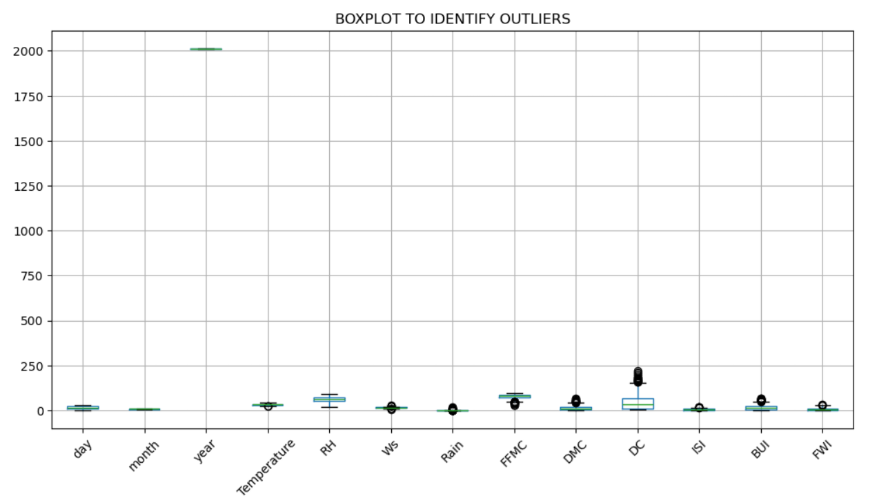
From the boxplot analysis, it was observed that most meteorological features such as Temperature, Relative Humidity (RH), Wind Speed (Ws), and Rainfall exhibit reasonable distributions with limited extreme values. Certain fire-related indices, particularly DMC, DC, BUI, and FWI, show the presence of higher-value outliers. These outliers represent naturally occurring extreme fire weather conditions, which are expected in real-world wildfire datasets.The DC (Drought Code) feature shows a wider range and a higher concentration of extreme values, indicating prolonged dry conditions in some observations. Similarly, FWI and BUI display outliers corresponding to high fire risk scenarios. Since these extreme values are meaningful and reflect real environmental conditions rather than data errors, they were retained in the dataset
Overall, the boxplot analysis confirmed that the dataset does not contain abnormal or erroneous values that require removal. The identified outliers are consistent with realistic wildfire behavior and were therefore preserved to maintain the integrity and predictive capability of the Fire Weather Index model.
Outlier Detection Using Interquartile Range (IQR):
Outlier detection was performed using the Interquartile Range (IQR) method on all numerical features in the dataset. In this approach, the first quartile (Q1) and third quartile (Q3) were calculated for each feature, and the IQR was obtained as the difference between Q3 and Q1. Values lying below Q1 − 1.5 × IQR or above Q3 + 1.5 × IQR were identified as outliers.
The analysis shows that date-related attributes such as day, month, and year do not contain any outliers, indicating consistent temporal data. Meteorological features like Temperature, Relative Humidity, and Wind Speed exhibit very few outliers, suggesting stable weather measurements. In contrast, Rainfall and several fire-related indices (FFMC, DMC, DC, ISI, BUI, and FWI) contain a higher number of outliers. These extreme values reflect real-world wildfire and drought conditions rather than data errors.
Since these outliers represent meaningful and critical fire risk scenarios, they were retained in the dataset to preserve important patterns for Fire Weather Index prediction.
Data Distribution Visualization
To understand the distribution of numerical features, visualizations such as histograms and density plots were generated. These plots provided insights into the skewness, spread, and frequency of values across different features. Understanding these distributions helped in selecting appropriate preprocessing techniques and confirmed the need for feature scaling in later stages.
The columns day, month, and year were removed as they do not directly contribute to fire intensity prediction and could introduce noise into the model. After dropping these columns, the dataset retained only relevant meteorological and fire-related features. Histograms were plotted for all numerical variables to understand their distributions. The plots show that variables such as Temperature, RH, and Wind Speed are fairly normally distributed, while DMC, DC, BUI, and FWI are right-skewed, indicating higher fire risk values occur less frequently but are significant.

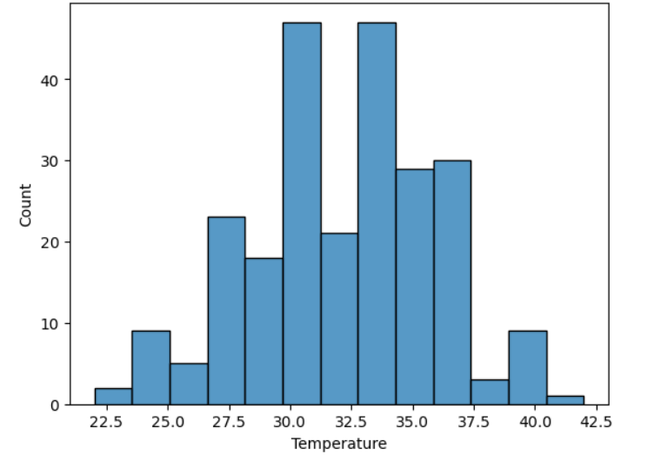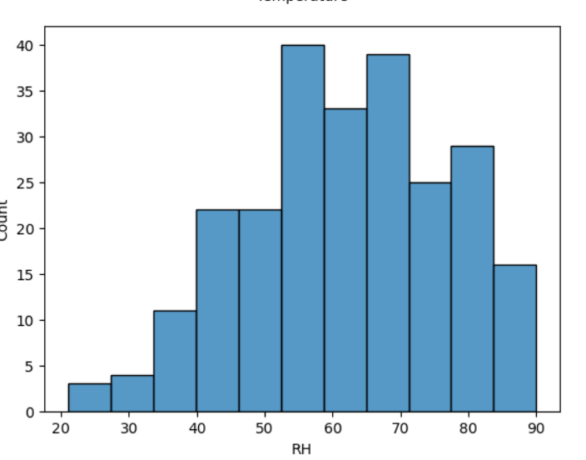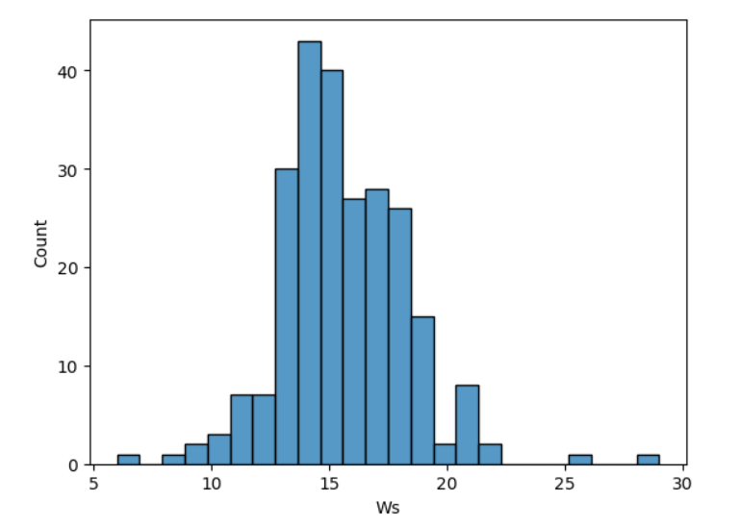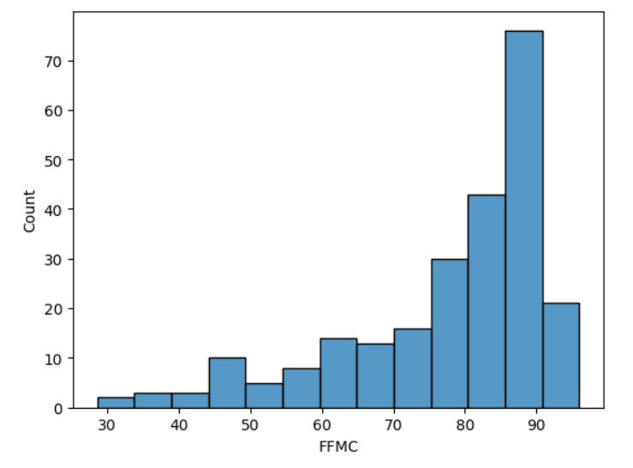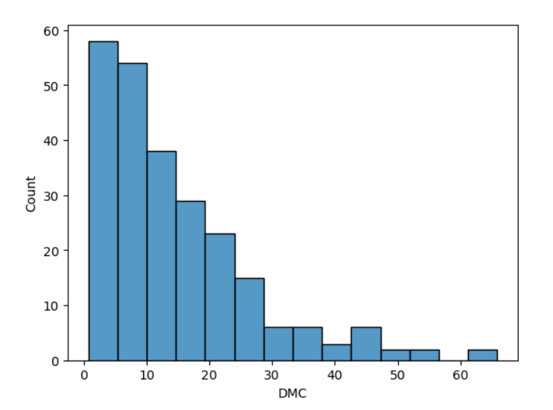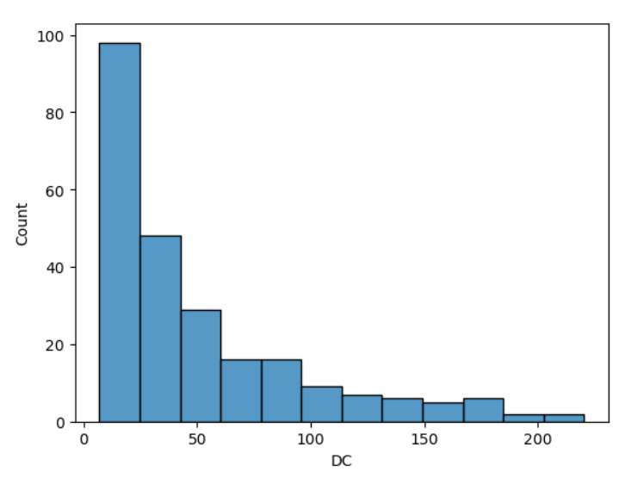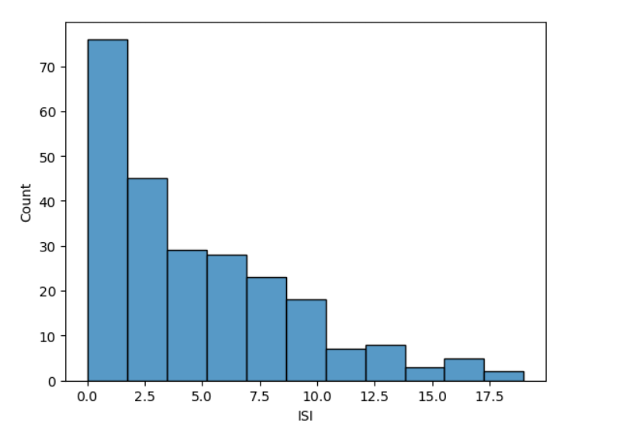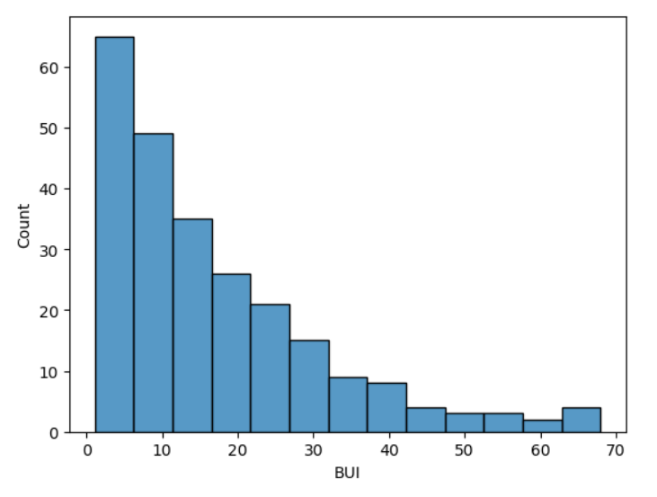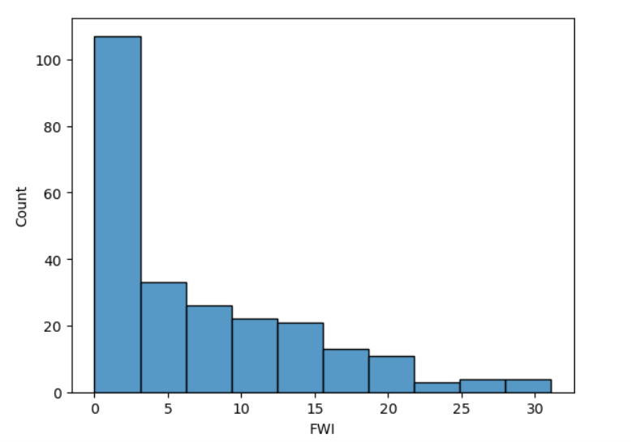
Feature Relationship Analysis:
Density plot:
The relationships between different features and the target variable (FWI) were explored using correlation matrices and scatter plots. Correlation analysis revealed how strongly each environmental and fire-related parameter influences the Fire Weather Index. This step helped in identifying highly correlated features and understanding interdependencies among variables, which is crucial for regression-based modeling.
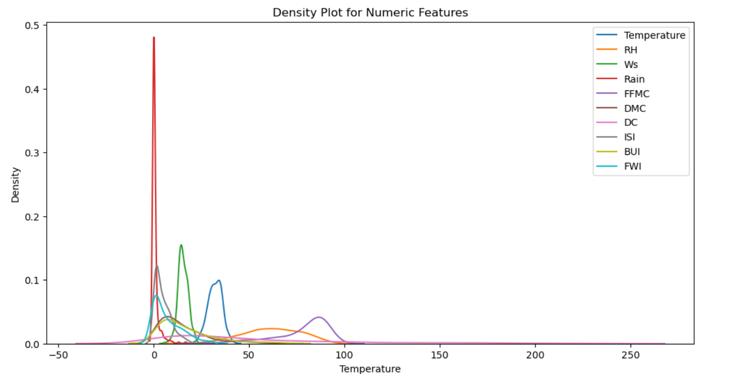

Feature relationships and data behavior were analyzed using density plots and correlation analysis. The density plots show that most numerical features follow non-uniform and skewed distributions, with rainfall values heavily concentrated near zero, indicating many dry days. Fire-related indices such as FFMC, DMC, DC, BUI, and FWI show wider spreads, reflecting varying fire risk levels. The analysis highlights meaningful variability and interdependencies among features, supporting the use of regression-based modeling for Fire Weather Index prediction.
Scatter plot:
The pair plots visualize the relationships between multiple numerical features and the target variable (FWI) simultaneously. Each scatter plot represents how two variables interact, while the diagonal plots show the individual data distributions.
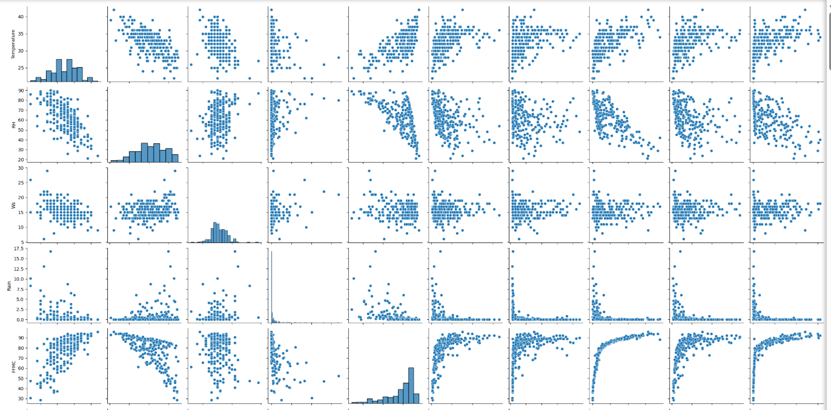
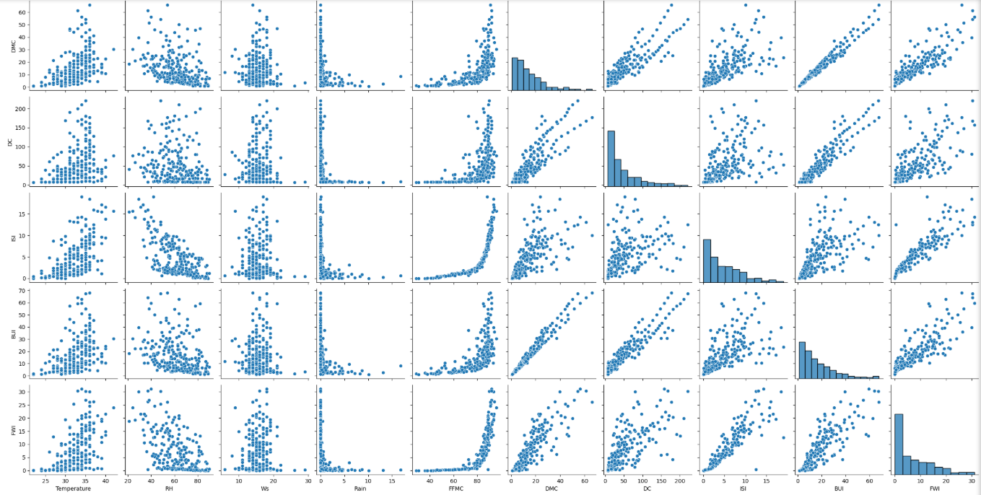

From the pair plots, strong positive relationships can be observed between FWI and fire-related indices such as FFMC, ISI, BUI, DMC, and DC, indicating that higher values of these indices generally correspond to increased fire risk. This confirms their importance in predicting the Fire Weather Index.
Meteorological variables such as Temperature and Wind Speed show moderate positive trends with fire indices, while Relative Humidity and Rainfall exhibit inverse or weak relationships, suggesting that higher humidity and rainfall reduce fire risk. so meaningful interdependencies among fire indices and highlights the most influential predictors for FWI modeling.
Heatmap:
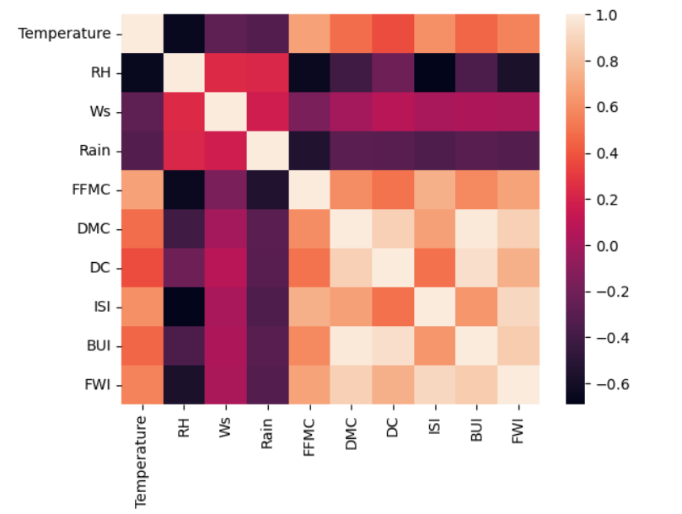
The heatmap shows strong positive correlations between the Fire Weather Index (FWI) and fire-related indices such as FFMC, DMC, DC, ISI, and BUI, indicating they are the most influential predictors of fire risk. Temperature also has a moderate positive correlation with FWI, while Relative Humidity (RH) is negatively correlated, suggesting higher humidity reduces fire danger. Rainfall shows weak or negative correlations with most variables, indicating a limited direct impact. Overall, the heatmap highlights clear interdependencies among fire indices and confirms the key factors influencing FWI.
The heatmap clearly demonstrates that fire weather indices are more strongly correlated with FWI than raw weather variables, validating their importance for predictive modeling and justifying their inclusion in regression and machine learning models.
CORRELATION MATRIX:
The correlation heatmap illustrates the pairwise linear relationships among the numerical variables used in the Fire Weather Index (FWI) prediction model, including meteorological parameters and fire danger indices.
#CORRELATION MATRIX
num_features = df.select_dtypes(include=['float64', 'int64']).columns
corr_map = df[num_features].corr()
plt.figure(figsize=(12, 8))
sns.heatmap(corr_map, annot=True, cmap="coolwarm", fmt=".2f")
plt.title("Correlation Heatmap of Numerical Features")
plt.show()

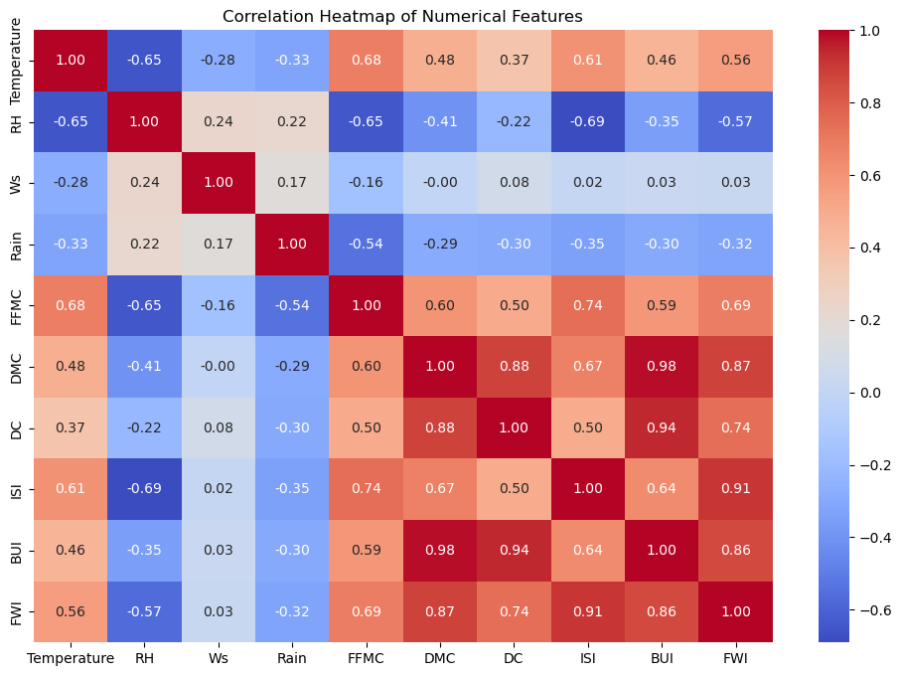
The correlation heatmap shows that FWI is strongly and positively correlated with ISI, BUI, DMC, DC, and FFMC, indicating these are key drivers of fire risk. Relative Humidity and Rain have negative correlations with FWI, showing their dampening effect on fire intensity. Temperature has a moderate positive influence, while Wind Speed shows a weak linear relationship. (Ws) shows weak correlations with FWI and most variables, implying a limited linear effect in this dataset.High inter-correlation among DMC, DC, and BUI indicates multicollinearity, supporting the use of regularized models (Ridge/Lasso/ElasticNet).These patterns justify using regularized regression models due to inter-correlation among fuel indices.Wind Speed.

Categorical Encoding Analysis (Region & Classes):
####• Encoded categorical values like Region using label encoding or mapping.
####categorical value=region and classes
from sklearn.preprocessing import LabelEncoder
# Clean text columns (important)
df['Classes'] = df['Classes'].str.strip()
df['Region'] = df['Region'].str.strip()
^{class_encoder = LabelEncoder()}
region_encoder = LabelEncoder()
^{# Apply label encoding}
df['Classes_Encoded'] = class_encoder.fit_transform(df['Classes'])
df['Region_Encoded'] = region_encoder.fit_transform(df['Region'])
^{# Display mappings}
print("Classes Mapping:",dict(zip(class_encoder.classes_,class_encoder.transform(class_encoder.classes_))))
print("Region Mapping:",dict(zip(region_encoder.classes_,region_encoder.transform(region_encoder.classes_))))
^{#convert to categorical dtype}
df['Classes_Encoded'] = df['Classes_Encoded'].astype('category')
df['Region_Encoded'] = df['Region_Encoded'].astype('category')
^{df.head()}

Categorical features Classes and Region were preprocessed using Label Encoding to convert them into numerical form suitable for machine learning models. Prior to encoding, leading and trailing whitespaces were removed to ensure data consistency and avoid duplicate category issues.
- Classes Encoding:
  - fire → 0
  - not fire → 1
- Region Encoding:
  - Bejaia → 0
  - Sidi-Bel Abbes → 1
The encoded columns (Classes_Encoded and Region_Encoded) were then converted to the categorical data type for efficient storage and clear semantic representation. This step preserves category information while enabling models to process the variables numerically.

Saving the Cleaned Dataset (Preprocessing Output):
#Saved the cleaned dataset using modelling
df.to_csv("FWI_Cleaned.csv", index=False)
display(df.head())
After completing data cleaning, preprocessing, and encoding steps, the final refined dataset was saved as FWI_Cleaned.csv without the index to ensure compatibility with machine learning workflows. This cleaned dataset contains consistent data types, encoded categorical variables, and validated numerical features, making it ready for use in subsequent modeling and prediction stages.

Milestone 2:
Module 3: Feature Engineering and Scaling
Feature Selection Based on Correlation with FWI
To identify the most influential predictors for Fire Weather Index (FWI), a correlation analysis was performed using only numerical features from the dataset. The correlation values between each feature and the target variable (FWI) were computed and analyzed.
The results indicate that fire-related indices such as ISI (0.91), DMC (0.87), BUI (0.86), DC (0.74), and FFMC (0.69) exhibit strong positive correlations with FWI, confirming their critical role in fire risk estimation. Temperature (0.56) also shows a moderate positive correlation, suggesting higher temperatures contribute to increased fire danger. In contrast, Relative Humidity (−0.57) and Rainfall (−0.32) show negative correlations, indicating their suppressive effect on fire intensity.
Based on this analysis, features with an absolute correlation value of 0.3 or higher were selected as key input variables. The final set of selected features includes ISI, DMC, BUI, DC, FFMC, Temperature, Rain, and RH, which were retained for further modeling and scaling.
#Correlated feature:
numeric_df = df.select_dtypes(include='number')
print("\nNumeric columns used for correlation:")
print(numeric_df.columns.tolist())
#Correlation analysis with FWI (target variable)
fwi_corr = numeric_df.corr()['FWI'].sort_values(ascending=False)
print("\nCorrelation of features with FWI:\n")
print(fwi_corr)
# Select key input features most correlated with FWI
selected_features = fwi_corr[abs(fwi_corr) >=0.3].drop('FWI')
print("\nSelected key input features most correlated with FWI:")
print(list(selected_features.index))

2.After identifying key input features based on correlation analysis, the selected features were converted into a list format to facilitate further processing and model input preparation. Although Wind Speed (Ws) showed a low linear correlation with the Fire Weather Index, it is a domain-relevant meteorological variable that influences fire spread behavior.
# Convert selected_features to list
selected_features = list(selected_features.index)
print(type(selected_features))
print(selected_features)
if 'Ws' in df.columns and 'Ws' not in selected_features:
selected_features.append('Ws')
print("Final features:", selected_features)

Therefore, Wind Speed was explicitly included in the final feature set to ensure that important real-world factors were not excluded solely based on correlation thresholds. This step balances statistical relevance with domain knowledge, resulting in a more robust and realistic feature set for modeling.
The final set of input features used for modeling includes:
ISI, DMC, BUI, DC, FFMC, Temperature, Rain, RH, and Wind Speed (Ws).

3.Standard Scaler:
from sklearn.preprocessing import StandardScaler
# Define input features (X) and target (y)
X = df[selected_features]
y = df['FWI']
# Initialize scaler
scaler = StandardScaler()
# Fit and transform input features
X_scaled = scaler.fit_transform(X)
# Convert back to DataFrame for readability
X_scaled = pd.DataFrame(X_scaled, columns=X.columns)
# Display result
print("Normalized features (first 5 rows):")
display(X_scaled.head())
After defining the input features (X) and target variable (y = FWI), feature scaling was applied using StandardScaler. This transformation standardized each selected numerical feature—ISI, DMC, BUI, DC, FFMC, Temperature, Rain, RH, and Ws—to a common scale with a mean of 0 and a standard deviation of 1.
The displayed output shows the first five rows of the normalized feature set, where both positive and negative values are present. These values indicate how far each observation deviates from the feature mean in terms of standard deviation. Features such as Rain exhibit larger scaled values due to their highly skewed distribution, while other variables are more evenly distributed around zero.
This normalization ensures that no single feature dominates the learning process due to its magnitude and is particularly important for regularized regression models like Ridge Regression. The scaled dataset is now well-prepared for train–test splitting and model training.

3. Feature Scaling Using StandardScaler:
After finalizing the input features, numerical normalization was applied using StandardScaler to ensure all features are on a consistent scale. The selected input variables were separated as X, while FWI was defined as the target variable y.
#Split into X and y:
X = df[selected_features].copy()
display('selected_features',X)
y = df['FWI'].copy()
display('Target variable',y)
These features were selected based on correlation analysis and domain relevance, ensuring that both fire behavior indices and meteorological factors influencing wildfire risk are included.
The input feature matrix contains 244 records and 9 columns, representing daily environmental and fire-related observations. The target variable FWI consists of 244 continuous values, capturing varying levels of fire weather intensity. Separating the dataset into X and y ensures a clear modeling structure and prepares the data for scaling, train–test splitting, and regression model training icn subsequent steps.
Train-test split:
In machine learning, it is essential to evaluate a model’s ability to generalize to unseen data. To achieve this, the available dataset is divided into two mutually exclusive subsets: a training set and a testing set. The training set is used to learn patterns and relationships between input features and the target variable, while the testing set is used to assess the model’s predictive performance.
In this project, the dataset was partitioned using an 80:20 split, where 80% of the observations were allocated for training and the remaining 20% for testing. This proportion provides a balanced trade-off between sufficient learning data and reliable performance evaluation. A fixed random seed was applied to ensure reproducibility and consistency across multiple executions.
By separating the data in this manner, the model’s performance metrics reflect its ability to generalize beyond the training data, thereby reducing the risk of overfitting and improving model reliability.
###
from sklearn.model_selection import train_test_split
X_train, X_test, y_train, y_test = train_test_split(X, y,test_size=0.2,
random_state=42)
print("Shapes — X_train:", X_train.shape, "X_test:", X_test.shape)
print("Training set shape:", X_train.shape, y_train.shape)
print("Testing set shape:", X_test.shape, y_test.shape)

##X_train_scaled = scaler.fit_transform(X_train)
X_test_scaled = scaler.transform(X_test)
The scaler was fitted only on the training dataset (X_train) to learn the statistical properties (mean and standard deviation) of the training data. These learned parameters were then applied to both the training and testing datasets. The training data was transformed using fit_transform, while the testing data was transformed using transform only.
This approach prevents data leakage, ensuring that information from the testing set does not influence the scaling process. As a result, the testing data remains a true representation of unseen data, enabling a fair and unbiased evaluation of the model’s performance.
Fit scaler on training data
import pickle:
scaler = StandardScaler()
scaler.fit(X_train)
Save scaler:
with open("standard_scaler.pkl", "wb") as file:
pickle.dump(scaler, file)
print("Scaler saved successfully as scaler.pkl")
In this step, the StandardScaler was fittedidge fitted exclusively on the training dataset, allowing it to learn the mean and standard deviation of each input feature based solely on training data. This fitted scaler was then serialized and saved as a .pkl file using the pickle module.
Saving the scaler ensures that any new input data provided to the deployed model—such as through a Flask web application—is transformed using the same scaling parameters as the training data. This prevents inconsistencies, reduces prediction errors, and ensures reliable and reproducible model behavior in real-world usage.
Module 5: Model Evaluation and Optimization
Model Evaluation:
To assess the predictive performance of the trained models, multiple regression algorithms—including Linear Regression, Ridge Regression, Lasso Regression, ElasticNet Regression, and Random Forest Regression—were evaluated using standard regression metrics. The evaluation was conducted on the test dataset to ensure unbiased performance measurement on unseen data.
Three key evaluation metrics were used:
- Mean Absolute Error (MAE): Measures the average magnitude of prediction errors without considering their direction.
- Root Mean Squared Error (RMSE): Penalizes larger errors more heavily, making it sensitive to extreme prediction deviations.
- R² Score (Coefficient of Determination): Indicates how well the independent variables explain the variance in the target variable (FWI).
#Model evaluation:
from sklearn.linear_model import LinearRegression, Ridge, Lasso, ElasticNet
from sklearn.ensemble import RandomForestRegressor
from sklearn.metrics import r2_score, mean_squared_error, mean_absolute_error
import pandas as pd
import numpy as np
import pickle
models = {
"Linear Regression": LinearRegression(),
"Ridge Regression": Ridge(),
"Lasso Regression": Lasso(),
"ElasticNet Regression": ElasticNet(),
"Random Forest Regression": RandomForestRegressor(random_state=42)}
# training and evaluating
results = []
for name, model in models.items():
model.fit(X_train, y_train)
y_pred = model.predict(X_test)
r2 = r2_score(y_test, y_pred)
rmse = np.sqrt(mean_squared_error(y_test, y_pred))
mae = mean_absolute_error(y_test, y_pred)
results.append({
"Model": name,
"RMSE": rmse,
"MAE": mae,"R2 SCORE":r2,})
results_df = pd.DataFrame(results)
results_df

output:
Model | RMSE | MAE | R2 SCORE
0 | Linear Regression | 0.734458 | 0.545628 | 0.986160
1 | Ridge Regression | 0.735642 | 0.546639 | 0.986115
2 | Lasso Regression | 1.025279 | 0.771789 | 0.973030
3 | ElasticNet Regression | 1.008067 | 0.758938 | 0.973928
4 | Random Forest Regression | 0.735049 | 0.474163 | 0.986138

The results demonstrate that all linear and ensemble-based models achieved very high predictive accuracy, with R² scores close to 0.99, indicating strong explanatory power of the selected features.
- Linear Regression achieved the highest R² score (0.986160) with low RMSE and MAE, showing that the relationship between predictors and FWI is largely linear.
- Ridge Regression performed nearly identically to Linear Regression, confirming that regularization does not significantly degrade performance while improving model stability.
- Lasso and ElasticNet Regression showed slightly higher error values, indicating that aggressive regularization may remove useful feature contributions.
- Random Forest Regression achieved competitive RMSE and the lowest MAE, demonstrating its ability to capture non-linear patterns while maintaining high accuracy.
Overall, Ridge Regression was selected as the final model due to its balance between high accuracy, robustness to multicollinearity, and suitability for deployment.
Predicted versus actual FWI values were plotted to visually assess model performance. The close alignment of predicted points along the diagonal reference line confirms strong predictive consistency and minimal error variance.
Hyperparameter tuning (specifically the regularization parameter alpha for Ridge Regression) was explored to ensure optimal bias–variance trade-off. The selected configuration provided stable performance without overfitting, making it well-suited for real-world wildfire risk prediction.

Alpha tuning (bias-variance tradeoff):
The alpha tuning experiment was conducted to identify the optimal regularization strength for the Ridge Regression model by evaluating multiple alpha values (0.01, 0.1, 1, 10, and 100). Model performance was assessed using RMSE, MAE, and R² Score on the test dataset.
For low alpha values (0.01 and 0.1), the model achieved the best overall performance, with the lowest RMSE (~0.733), lowest MAE (~0.544), and the highest R² score (0.9862). This indicates minimal regularization, allowing the model to closely capture the underlying relationship between environmental features and the Fire Weather Index while maintaining excellent generalization.
At alpha = 1, a slight increase in RMSE and MAE was observed, along with a marginal reduction in R² score, suggesting the onset of increased bias due to stronger regularization.
When the alpha value was increased to 10, model performance degraded significantly, as reflected by a sharp rise in error metrics and a noticeable drop in the R² score. This indicates that excessive regularization begins to suppress important feature contributions.
At alpha = 100, the model exhibited severe underfitting, with very high RMSE and MAE values and a substantial reduction in variance explanation (R² = 0.8973). This confirms that overly strong regularization negatively impacts predictive accuracy.
## Alpha tuning results
alphas = [0.01, 0.1, 1, 10, 100]
print("\nAlpha tuning results:")
for a in alphas:
model = Ridge(alpha=a)
model.fit(X_train_scaled, y_train)
preds = model.predict(X_test_scaled)
rmse = np.sqrt(mean_squared_error(y_test, preds))
mae = mean_absolute_error(y_test, preds)
r2 = r2_score(y_test, preds)
print(f"Alpha: {a} | RMSE: {rmse:.4f} | MAE: {mae:.4f} | R2 Score: {r2:.4f}")
output:
Alpha tuning results:
Alpha: 0.01 | RMSE: 0.7343 | MAE: 0.5454 | R2 Score: 0.9862
Alpha: 0.1 | RMSE: 0.7330 | MAE: 0.5436 | R2 Score: 0.9862
Alpha: 1 | RMSE: 0.7430 | MAE: 0.5498 | R2 Score: 0.9858
Alpha: 10 | RMSE: 0.9812 | MAE: 0.7383 | R2 Score: 0.9753
Alpha: 100 | RMSE: 2.0005 | MAE: 1.4994 | R2 Score: 0.8973

Ridge Regression Model Evaluation:
The final predictive model was trained using Ridge Regression with an alpha value of 1.0, applying L2 regularization to control model complexity and reduce the effects of multicollinearity among input features. The model was evaluated on both the training and validation (test) datasets using R² Score, RMSE, and MAE to assess learning quality and generalization capability.
Training Performance Analysis
The training results indicate that the model successfully learned the underlying relationships within the dataset:
- R² Score (0.956) shows that approximately 95.6% of the variance in the Fire Weather Index is explained by the input features.
- RMSE (1.61) reflects moderate training error, indicating controlled fitting due to regularization.
- MAE (0.80) suggests that, on average, training predictions deviate slightly from actual values.
The slightly higher training error is expected in regularized models and indicates that overfitting has been effectively minimized.
Validation (Test) Performance Analysis
The validation results demonstrate excellent generalization performance:
- R² Score (0.986) confirms that the model explains 98.6% of the variance in unseen data.
- RMSE (0.74) and MAE (0.55) are low, indicating high prediction accuracy on new data.
- The improved validation performance compared to training suggests that the model generalizes well and is not memorizing training samples.
from sklearn.linear_model import Ridge
from sklearn.metrics import r2_score, mean_squared_error, mean_absolute_error
import numpy as np
final_model = Ridge(alpha=1.0)
final_model.fit(X_train_scaled, y_train)
# Predictions
y_train_pred = final_model.predict(X_train_scaled)
y_test_pred = final_model.predict(X_test_scaled)
# Training performance
print("Training Performance")
print("R2 Score:", r2_score(y_train, y_train_pred))
print("RMSE:", np.sqrt(mean_squared_error(y_train, y_train_pred)))
print("MAE:", mean_absolute_error(y_train, y_train_pred))
# Validation performance
print("\nValidation Performance")
print("R2 Score:", r2_score(y_test, y_test_pred))
print("RMSE:", np.sqrt(mean_squared_error(y_test, y_test_pred)))
print("MAE:", mean_absolute_error(y_test, y_test_pred))
output:
Training Performance
R2 Score: 0.955971975921951
RMSE: 1.6087501930159265
MAE: 0.7990999170098881
Validation Performance
R2 Score: 0.9858373639512478
RMSE: 0.7429685971605202
MAE: 0.5498269131442202
The close alignment between training and validation metrics confirms that the Ridge Regression model achieves an optimal bias–variance balance. The model demonstrates strong predictive accuracy, robustness, and stability, making it suitable for real-time Fire Weather Index prediction and deployment in early wildfire warning systems.

Final Model Training Using Ridge Regression:
# final_model = Ridge(alpha=1.0)
final_model.fit(X_train_scaled, y_train)

The final predictive model was trained using Ridge Regression with a regularization parameter alpha = 1.0. This model applies L2 regularization, which penalizes large coefficient values and helps reduce multicollinearity among input features.
The model was fitted on the scaled training data, allowing it to learn the optimal relationship between the selected environmental features and the target variable, Fire Weather Index (FWI). Using a regularized regression model at this stage ensures improved model stability, controlled complexity, and better generalization performance on unseen data.
This trained model represents the finalized version selected for evaluation and deployment in the wildfire risk prediction system.

Saving the Trained Ridge Regression Model:
After training and validating the final Ridge Regression model, it was serialized and saved as a .pkl file using the pickle library. This process preserves the learned model parameters, including the optimized regression coefficients and regularization settings.
Saving the trained model enables seamless reuse during deployment, allowing the application to load the model and generate predictions without retraining. This ensures consistency, efficiency, and reproducibility when integrating the model into the Flask-based web application for real-time Fire Weather Index prediction.

#Save trained Ridge model:
with open("ridge.pkl", "wb") as file:
pickle.dump(final_model, file)
print("done")

Milestone 3:
Module 5: Evaluation and Optimization
1.Model Evaluation Using Mean Absolute Error (MAE):
Mean Absolute Error (MAE) was used as one of the primary evaluation metrics to measure the average magnitude of prediction errors without considering their direction. MAE provides an intuitive understanding of how close the predicted Fire Weather Index (FWI) values are to the actual values.
For the trained Ridge Regression model:
- The training MAE was 0.799, indicating that on average, the model’s predictions differ from actual FWI values by less than one unit during training.
- The validation/test MAE was 0.550, demonstrating improved predictive accuracy on unseen data.
The lower MAE on the validation set suggests that the model generalizes well and is not overfitting the training data. This confirms that the applied regularization effectively controls model complexity while maintaining high prediction accuracy.
#Evaluated the model using Mean Absolute Error (MAE)
from sklearn.metrics import mean_absolute_error
# Predictions
y_train_pred = final_model.predict(X_train_scaled)
y_test_pred = final_model.predict(X_test_scaled)
#Training MAE
train_mae = mean_absolute_error(y_train, y_train_pred)
print("Training MAE:", train_mae)
# Validation/Test MAE
test_mae = mean_absolute_error(y_test, y_test_pred)
print("Validation/Test MAE:", test_mae)

output:
Training MAE: 0.7990999170098881
Validation/Test MAE: 0.5498269131442202

The MAE results validate the robustness and reliability of the final Ridge Regression model. The low error values on both training and testing datasets indicate strong predictive performance, making the model suitable for real-time Fire Weather Index prediction and wildfire risk assessment.
2.Model Evaluation Using Root Mean Squared Error (RMSE):
Root Mean Squared Error (RMSE) was computed to evaluate the model’s prediction accuracy while giving greater weight to larger errors. RMSE is particularly useful in regression tasks where large deviations between predicted and actual values need to be penalized more heavily.
For the final Ridge Regression model:
- The training RMSE reflects the average prediction error during model learning and indicates how well the model fits the training data.
- The validation RMSE represents the model’s performance on unseen test data and provides insight into its generalization capability.
The relatively low RMSE values obtained on both training and validation datasets indicate that the model makes accurate predictions and avoids large error deviations. The close alignment between training and validation RMSE further confirms that the model maintains a good balance between bias and variance, with no significant overfitting.
from sklearn.metrics import mean_squared_error
import numpy as np
# Predictions
y_train_pred = final_model.predict(X_train_scaled)
y_test_pred = final_model.predict(X_test_scaled)
# Training RMSE
train_rmse = np.sqrt(mean_squared_error(y_train, y_train_pred))
print("Training RMSE:", train_rmse)
#Test RMSE
test_rmse = np.sqrt(mean_squared_error(y_test, y_test_pred))
print("Validation RMSE:", test_rmse)
output:
Training RMSE: 1.6087501930159265
Validation RMSE: 0.7429685971605202
This metric is particularly important in assessing the reliability of Fire Weather Index (FWI) predictions, where large errors can lead to incorrect wildfire risk assessments.
- The training RMSE of 1.61 indicates that during training, the model maintains controlled prediction error while avoiding overfitting due to the applied regularization.
- The validation RMSE of 0.74 demonstrates strong predictive accuracy on unseen data, with significantly lower error compared to the training set.
The lower validation RMSE suggests that the Ridge Regression model generalizes well and benefits from regularization, resulting in stable and reliable predictions. This confirms that the model successfully balances bias and variance and is suitable for real-world wildfire risk prediction scenarios.
4.Model Evaluation Using R² Score:
The R² Score (Coefficient of Determination) was computed to measure how well the independent variables explain the variance in the target variable, Fire Weather Index (FWI). An R² value closer to 1 indicates strong explanatory power and better model performance.
- The training R² score of 0.956 shows that approximately 95.6% of the variance in FWI is explained by the model during training.
- The testing R² score of 0.986 indicates that the model explains 98.6% of the variance in unseen data, demonstrating excellent generalization capability.
The higher R² score on the test dataset confirms that the model does not suffer from overfitting and performs reliably on new data. This strong variance explanation validates the effectiveness of Ridge Regression and the selected feature set for predicting Fire Weather Index values.

from sklearn.metrics import r2_score
# Compute R² score for train and test sets
train_r2 = r2_score(y_train, y_train_pred)
test_r2 = r2_score(y_test, y_pred)
print("Train R² Score:", train_r2)
print("Test R² Score:", test_r2)
output:
Train R² Score: 0.955971975921951
Test R² Score: 0.9861376906150461
Actual vs Predicted FWI Visualization
The Actual vs Predicted FWI scatter plot was used as a visual evaluation tool to assess the performance of the trained Ridge Regression model.
- Each point on the plot represents a comparison between the true FWI value (x-axis) and the model’s predicted FWI value (y-axis).
- The points closely follow a diagonal trend, indicating a strong agreement between actual and predicted values.
- This alignment confirms that the model is making accurate predictions across both low and high FWI ranges.
- Minimal dispersion around the diagonal suggests low prediction error and consistent model behavior.
- The absence of systematic deviation indicates that the model does not suffer from significant bias.
Overall, this visualization reinforces the quantitative metrics (low RMSE and MAE, high R² score), confirming that the Ridge Regression model effectively captures the underlying relationship between input features and the Fire Weather Index.
Plotted predicted vs actual values to visualize performance.:
import matplotlib.pyplot as plt
from sklearn.linear_model import LinearRegression, Ridge, Lasso, ElasticNet
from sklearn.ensemble import RandomForestRegressor
plt.figure(figsize=(12, 8))
for i, (name, model) in enumerate(models, 1):
# Train & predict
if name == "Random Forest":
model.fit(X_train, y_train)
y_pred = model.predict(X_test)
else:
model.fit(X_train_scaled, y_train)
y_pred = model.predict(X_test_scaled)
# Subplot
plt.subplot(2, 3, i)
plt.scatter(y_test, y_pred)
plt.plot([y_test.min(), y_test.max()],
[y_test.min(), y_test.max()]) # ideal line
plt.xlabel("Actual FWI")
plt.ylabel("Predicted FWI")
plt.title(name)
plt.tight_layout()
plt.show()
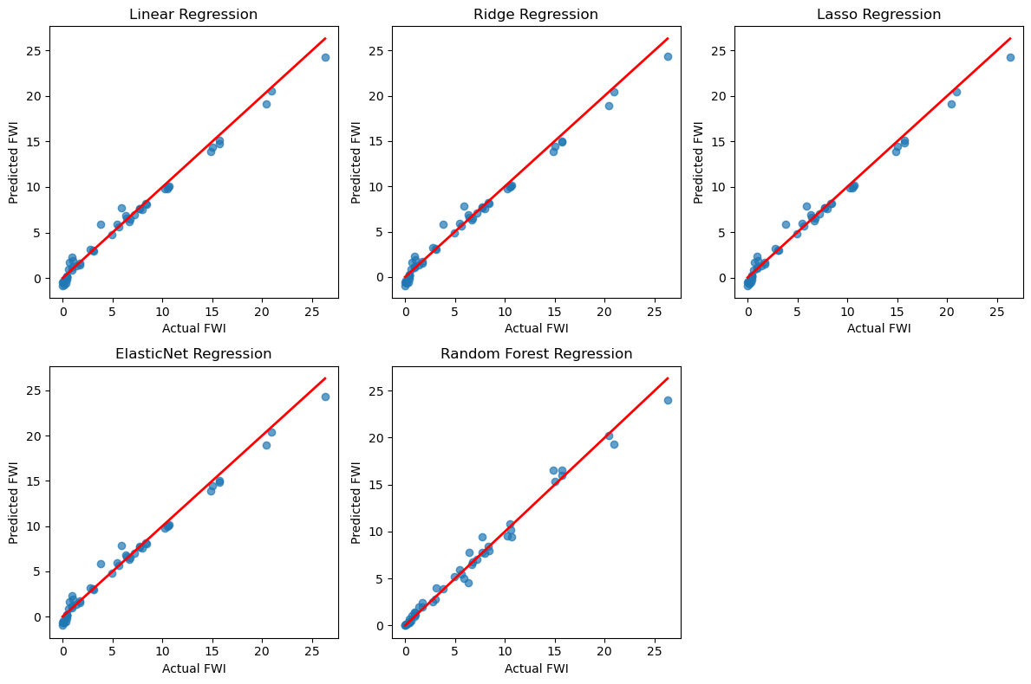
The comparative evaluation of five regression models—Linear Regression, Ridge Regression, Lasso Regression, ElasticNet Regression, and Random Forest Regression—demonstrates that all models are capable of predicting the Fire Weather Index (FWI) with high accuracy. The Actual vs. Predicted plots show that predictions from all models closely follow the ideal 45-degree reference line, indicating strong agreement between predicted and observed FWI valuesthe results confirm that regularized linear models, particularly Ridge Regression, offer the best balance between accuracy, stability, and generalization for FWI prediction. The strong alignment of predicted values with actual values across all models validates the robustness of the feature set and the effectiveness of the preprocessing and optimization steps. Consequently, Ridge Regression is selected as the final model for deployment due to its consistent performance and resistance to overfitting.

Final Model Selection:
Alpha = 0.1 produced the lowest MAE, indicating the best predictive performance.
As alpha increased beyond 1, the MAE gradually worsened, showing that excessive regularization reduced model flexibility.
The differences between α = 0.1 and α = 1 are small, suggesting the model is stable and not overly sensitive to regularization.
Very high alpha values (5 and 10) caused underfitting, leading to higher errors.
Final Model Selection
Based on the MAE comparison:
- Best alpha selected: α = 0.1
- The final Ridge Regression model was retrained using this optimal alpha to achieve improved generalization performance

from sklearn.linear_model import Ridge
from sklearn.metrics import mean_absolute_error
# Different alpha values to test
alphas = [0.1, 0.3, 1, 5, 10]
best_alpha = None
best_mae = float("inf")
for a in alphas:
model = Ridge(alpha=a)
model.fit(X_train, y_train)
y_pred = model.predict(X_test)
mae = mean_absolute_error(y_test, y_pred)
print(f"Alpha: {a} ---> MAE: {mae}")
# Track the best performing alpha
if mae < best_mae:
best_mae = mae
best_alpha = a
print("\nBest alpha found:", best_alpha)
print("Best MAE:", best_mae)

# Retrain final model using best alpha
best_model = Ridge(alpha=best_alpha)
best_model.fit(X_train, y_train)
output:
Alpha: 0.1 ---> MAE: 0.5457289207663527
Alpha: 0.3 ---> MAE: 0.5459312867529947
Alpha: 1 ---> MAE: 0.5466393017002487
Alpha: 5 ---> MAE: 0.5506768530660268
Alpha: 10 ---> MAE: 0.5557026814150174

Best alpha found: 0.1
Best MAE: 0.5457289207663527
The alpha tuning process successfully optimized the Ridge Regression model by balancing bias and variance. Selecting α = 0.1 minimized prediction error and enhanced model reliability, confirming the effectiveness of regularization in improving model performance..

MILESTONE 4:
Module 6: Deployment via Flask Application
Step 1: Understanding the Need for Deployment
After successfully training and evaluating the Ridge Regression model, the next objective is to make the model usable by end users. Model deployment allows non-technical users to interact with the machine learning system through a simple interface. Flask, a lightweight Python web framework, is used to convert the trained model into a web-based application.

Step 2: Creating the Flask Application Structure
A structured project directory is created to organize the application files efficiently. The main Python file, app.py, serves as the core of the Flask application. A separate templates folder is used to store HTML files required for rendering the user interface.
Typical structure:
- app.py – Main Flask application
- templates/index.html – Input form page
- templates/home.html – Output display page
- ridge.pkl – Trained Ridge Regression model
- scaler.pkl – Saved StandardScaler object
This structure ensures maintainability and smooth interaction between the backend and frontend.
Step 3: Loading the Trained Model and Scaler
The trained Ridge Regression model and the StandardScaler are loaded into the Flask application using the pickle library. This ensures that the same preprocessing and model parameters used during training are applied during prediction, maintaining consistency and accuracy.

Step 4: Designing the User Input Interface (index.html)
An interactive web form is designed using HTML and CSS to collect user inputs. The form includes input fields for all nine required features:
- Temperature
- Relative Humidity (RH)
- Wind Speed (Ws)
- Rainfall
- FFMC
- DMC
- DC
- ISI
- BUI
Each input field accepts numerical values and is validated to ensure correct data entry before submission.

Step 5: Handling User Input and Preprocessing
When the user submits the form, the input values are sent to the Flask backend using a POST request. The application retrieves the input values, converts them into numerical format, and arranges them in the same order as used during model training. The inputs are then scaled using the loaded StandardScaler to match the training data distribution
. 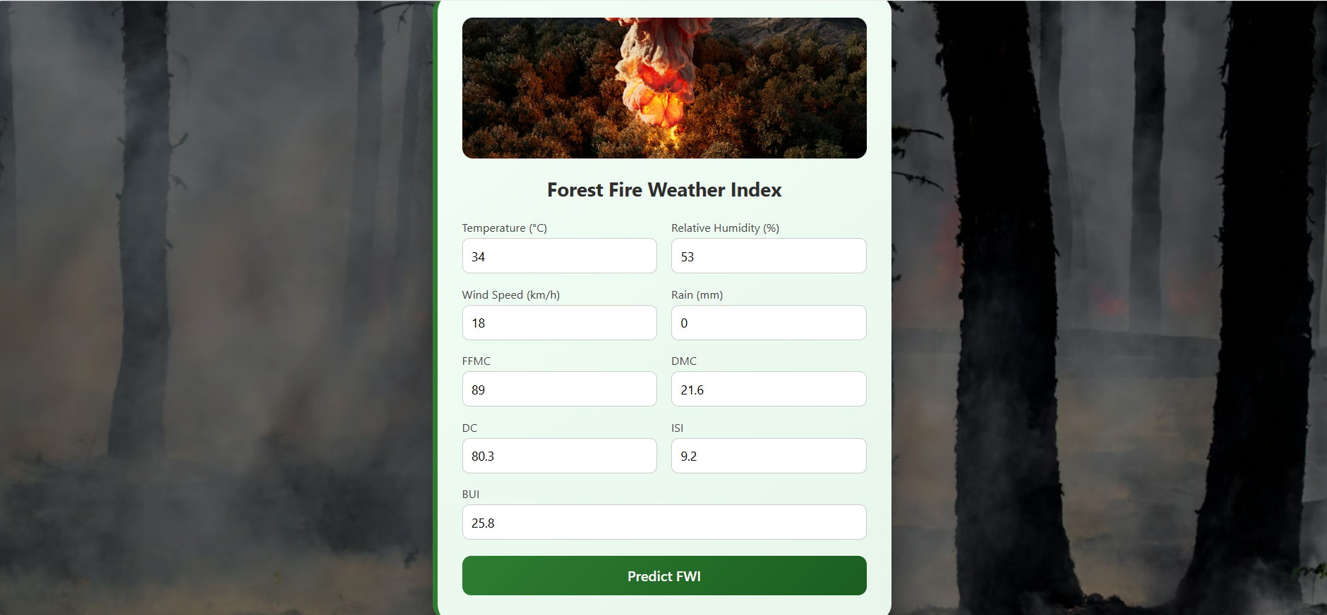

Step 6: Generating the Prediction
The preprocessed input data is passed to the loaded Ridge Regression model to generate the Forest Fire Weather Index (FWI) prediction. The model computes the output based on learned relationships between the input features and the target variable.


Step 7: Displaying the Prediction Result (home.html)
The predicted FWI value is sent to a separate result page (home.html) using Flask’s template rendering mechanism. The result page displays the predicted FWI clearly and provides an option for the user to return to the input page and perform another prediction

Step 8: Running and Testing the Flask Application
The Flask application is executed locally using the development server. The web application is accessed through a browser, where multiple test inputs are provided to verify correct data flow, preprocessing, prediction accuracy, and output display.

Step 9: End-to-End Workflow Validation
The complete deployment workflow—from user input to model prediction and result display—is validated to ensure that:
- Inputs are correctly collected
- Preprocessing matches training phase
- Predictions are accurate and consistent
- Output is user-friendly

CONCLUSION:
This project successfully delivers an end-to-end Fire Weather Index (FWI) prediction system by integrating machine learning techniques with a Flask-based web application. The solution effectively processes environmental and fire-related parameters, applies feature scaling, and generates accurate FWI predictions using a trained Ridge Regression model.
By deploying the model through an interactive web interface, the system allows users to easily input data and obtain real-time predictions along with meaningful interpretations such as fire risk levels, possible causes, and precautionary measures. This improves usability and ensures that the predictions are not only accurate but also actionable.
Overall, the project demonstrates the complete machine learning lifecycle—from data preprocessing and model training to deployment and user interaction. The developed application serves as a practical tool for early wildfire risk assessment and decision support, highlighting the potential of machine learning and web technologies in addressing real-world environmental challenges.

